Important points regarding Christ-intimacy

(discussed in the attached paper)

- The experience of the immanence of Christ is available to all believers.
- There are differing degrees of elevation (levels of experience) in this intimacy.
- There is a rich treasure of technical phrases (some new) that express this intimacy.
- These technical phrases in the Greek and Hebrew can be expressed pictorially.
- The light of the experience of Christ is entered into by the filling of the Spirit.
- The light of the experience of Christ is increased by learning doctrinal concepts.
- Both the divine sanctum and the cosmic sanctum can be represented by a sphere.
- There is one access gate into the divine sanctum: the filling of the Spirit.
- There are many access gates into the cosmic sanctum: categories of sin.
- How do you become filled with the Spirit? By the confession of sin (1 John 1:9).
- Christ-intimacy is increased by alternating doctrinal inculcation and suffering.
- Doctrinal inculcation and suffering for blessing require walking in the Spirit.
- There are permanent and temporary spheres of existence for believers.
- You can never lose permanent residence; you can lose temporal residence.
- Entrance is by the filling of the Spirit and progress is by walking in the Spirit.
- The spiritual life can be shown pictorially by a power sphere and gates.
- The spiritual life is successfully lived by utilizing ten problem-solving devices.

Christ-Intimacy

Christ in me, I in Christ

[This is not a research paper, because 99% of the contents have been typed verbatim from several resources named at the end. My contributions are in brackets or marked with an asterisk. The mechanics of the Christian way of life (i.e., Christ-intimacy or Occupation with Christ) has come a long way in the last century, as we shall see. First, we need some ground-breaking by L.S. Chafer.]

A fundamental distinction must be drawn between the believer’s union with Christ and his communion with Christ. The baptism of the Spirit at the moment of regeneration once and for all seals our union with Christ. Union with Christ is God’s undertaking and is wrought for, and continues as the portion of, the one who merely believes; communion is the believer’s undertaking – a specific plan of life which calls for an intelligent purpose and method of life, adapted to the precise will of God. This anticipates the right and true understanding of the Scriptures as well as the needed adjustments which secure divine power.

By the enabling power of the Holy Spirit some measure of the experience of divine love, divine joy, and divine peace yet to come may be secured now. So, likewise, the knowledge of God and especially that part which He has caused to be written down in Scripture may be entered into by the same Spirit. But when the heavenly sphere is entered, there will be an entrance into unbroken and undiminished divine love, joy, and peace, and a larger understanding which is comparable to that of God Himself. It is possible to come to know the Father by the gracious offices and effective working of the Son, and no soul has ever found true rest apart from this intimacy with God. It requires the Spirit’s filling. Not all Christians experience it and it must be renewed constantly. The filling depends upon personal adjustments.

When sin is tolerated in the Christian’s daily life, of necessity the Spirit must turn from His ministry through the Christian unto a pleading ministry to him. The cure is confession to God and the one who has aught to confess will not be left in doubt or uncertainty about what should be confessed. The message of 1 John 1:9 has to do with maintaining communion with the Father and with the Son. The bringing of the Christian into communion with God is not achieved by lowering that which pertains to God; it is rather gained by lifting the believer up to the level upon which communion with God is possible. Thus confession, which is the outward expression of inward repentance, becomes the one condition upon which a child of God who has been injured by sin may be restored to unbroken fellowship again.

In 1 Corinthians 11:31-32 the Father is seen to be waiting for the self-judgment or confession of His child who has sinned. God cannot walk in the dark with the believer, nor can fellowship be experienced when the believer is calling black white and white black. The Christian must agree with God that white is white and black is black. Having come into agreement with God (1 John 1:9), there remains no obstacle to hinder and fellowship is restored by the gracious forgiving and cleansing from God. The Spirit is grieved when sin occurs and remains unconfessed. The Spirit is quenched when the Christian resists or rejects the will of God for him. The appeal of 1 John 1:9 is to the human will; the human will determines the experiential course of the believer’s life. The whole doctrine of experimental sanctification depends upon it.

Abiding in Christ is not a matter of maintaining union with Christ, which union is secured rather by the Spirit’s baptism and endures as long as the merit of Christ endures, but a matter of maintaining communion with Christ. Abiding is continuance in the relationship wherein divine vitality may be imparted and God-honoring fruit may be borne. When thus related to Christ in unbroken communion, prayer is effectual, joy is celestial, and fruit is perpetual. This is the “life in Christ Jesus” (Rom. 8:2), that which is produced in the believer by the Spirit (Rom. 8:4). The strength which the believer possesses who is filled with the Spirit in communion with Christ is “in the Lord, and in the power of His might.”

The directing of the life of one already complete in Christ is technical to the last degree; yet all this has been unobserved to a distressing extent by theologians of past generations.

[Next we are going to study the technical directing of the life called experiential sanctification, or Christ-intimacy. Now let’s review a study by Adolph Deissmann which brings us to the use of pictorial teaching aids to better understand our communion with Christ in the filling of the Spirit.]

Christ intimacy is fellowship with Christ. Paul lives in Christ, in the living and present spiritual Christ, Who is about him on all sides, Who fills him, Who speaks to him, and speaks in and through him. He is not only a historical personage, but a reality and power of the present whose life-giving powers are daily expressing themselves in him.

The living Christ is the Pneuma. As Pneuma, as Spirit, the living Christ is not far off, above clouds and stars, but near; present on our poor earth He dwells and rules in His own. Christ is Spirit, therefore He can live in Paul and Paul in Him. Just as the air of life, which we breathe, is “in” us and fills us, and yet we at the same time live in this air and breathe it, so it is also with the Christ-intimacy of Paul: Christ in him, he in Christ.

The Lord is the Spirit,
The last Adam became a life-giving Spirit,
He that is joined to the Lord is one Spirit.
(2. Cor. 3:17, 1 Cor. 15:45, 6:17)

The formula “in the Spirit,” which occurs in Paul’s writings only 19 times, is in almost all these places connected with the same specifically Pauline fundamental ideas which elsewhere he connects with the formula “in Christ.” Also the technical expressions “fellowship of the Son of God” and “fellowship of the Spirit” are parallel in Paul’s use. The Christ-experience might be called in doctrinaire phrase the experience of the immanence of Christ.

The formula “in Christ” (or “in the Lord”) occurs 164 times in Paul’s writings: it is really the characteristic expression of his Christianity … the most intimate possible fellowship of the Christian with the living spiritual Christ. And it may reasonably be assumed that the Christ-intimacy of the Apostle itself had also its differing degrees of elevation. After the mountain peak of Damascus there followed the normal life in Christ, moving along a less exalted plane of personal experience, than in the rare times of trouble and consecration, when it rose again to a passionately intensified communion of prayer with the Savior.

Communion with the Spirit-Christ transforms all that we call the “historical” Christ, all that found its climax on Golgotha, all that had been entrusted to the Apostle as tradition about Jesus, into a present reality.

What Paul introduced into this Christ-intimacy was a rich treasure of technical phrases, which express often in popular pictorial language the spiritual communion between Christ and His own. The not unimportant problem of setting forth in order this technical vocabulary of Paul, a few details which we will sketch, has not yet been solved in all its bearings, and can be mentioned here only as an object of research.

In reality the wider ‘mystic’ circle “in Christ” lies like a concentric circle containing the older circle, as though protecting it and inviting to that holy of holies “in God,” which from now onwards appears really accessible “through Christ” and “in Christ.” In communion with Christ Paul found communion with God. Christ-intimacy was the experience and confirmation of God-intimacy.

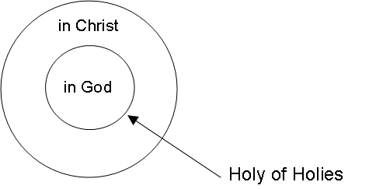

My energetic advocacy of the classification of Paul’s religion as ‘mysticism’ has had all sorts of results for me: sharp aversion and discord, which sometimes expressed itself in explosions of extreme irritation, personal following, at best of a romantic sort (which was no misfortune), at other times tending towards fanaticism (which for many is the most painful thing that earth produces), ridicule, elaborate irony, friendly caution. Looking back upon these experiences, and upon 30 years of most fruitful discussion with my students and at theological conferences and lecture courses in Germany, Sweden and England, it has become perfectly certain to me, that the explanation, which is certainly to be desired, is only possible, by first of all coming to an understanding as to the idea conveyed by mysticism. I ought to have done this before. We talk at cross purposes and over one another’s head if we do not do it.

[The term mysticism is often understood as a word with nothing but evil associations, such as isolated monks in some cave practicing esoteric rituals and meditative practices from questionable sources. Deissmann used the word in a wider sense, without such negative connotations … referring to the discovery of God, an immediacy of contact with Deity, fellowship with God, sanctification of personality through the presence of God, conforming of the human towards the divine, etc. A common theological term for his use of that word is experiential sanctification, a classification of doctrines related to Christ intimacy, which does not carry so much negative emotional baggage. I equate his understanding of the word “mysticism” to John Owen’s Communion With God the Father, Son, and Holy Spirit, Each Person Distinctly, In Love, Grace, and Consolation in Volume 2 of his works. I also equate it with residence and function inside the divine dynasphere, a teaching aid created by R.B. Thieme, Jr. that will be discussed later.]

The Pauline Christ-intimacy is no magic transformation, and it is no intoxication of ecstatic enthusiasts who are left as yawning sluggards when the transport is over. Rather, he who has “apprehended” Christ with deep humility comes into contact with His spiritual life-energy which directs us in the depths of our own being. Similarly, too, the gifts of the Spirit set before the saints of Paul’s churches mighty tasks: they who had “put on Christ” were daily to put Him on anew; and “in” this Christ only, that faith is of value whose energy is proved by love.

With the assurance of the Damascus “Christ in me” and the assurance of equal content “I in Christ,” an inexhaustible religion ‘energy’ was concentrated in the deep, and to religious impulses extremely sensitive, soul of the convert. In every direction Paul now radiated the “power of Christ” that ruled in him, gave out the “riches of Christ,” the “blessing of Christ,” and the “fullness of Christ” which had come to him.

It will strike many people as a strange idea to attempt to make Paul’s teaching understandable by means of diagrams. This will especially be so in the case of those who fail to recognize along what simple and vigorous lines Pauline thought moves. When first I thought over the synonymity of early Christian ideas, in setting forth somewhat fully Paul’s central convictions, I did not, it is true, give diagrams, but I described them clearly in order to explain the various methods of regarding the subject.

In every instance I then said, when endeavoring to represent this synonymity, the circle which is to enclose the related ideas must first be drawn; and the radii, which within each circle separate those related ideas from one another, must be drawn afterwards. The next question was whether one should make the line of the circle or that of the radii heavier. The dogmatic method which isolated the ‘concepts’ would draw the radial lines thick and the circumference thin. The psychological method, which emphasizes the close relationship in meaning of religious metaphor, would make the circumference heavy and the radii light.

More important than these methodological schemes are the possibilities of making Paul’s religious ideas themselves clear by graphic methods. Hans Leisegang even believes that Augustine himself in his statement (made after becoming acquainted with Paul), tanta se mihi philosophiae facies aperuit [“a great amount of my philosophy can be reproduced visibly”], hints that he had received a pictorial impression of Paul’s general scheme of thought. He also holds the opinion that Augustine’s thought itself is similarly capable of being represented pictorially. I am satisfied with the simplest of diagrams. I feel strongly that one has a right to use them. For Paul’s world of thought on religion is very strongly dominated by the category of space, which constantly finds expression in metaphor and is therefore graphically reproducible.

* The light of the experience of Christ is entered into by the filling of the Spirit. The importance of being “in Christ” is emphasized by the thick line of the sphere below as represented by the psychological method. The knowledge of Christ or doctrinal concepts are as yet in the background, as shown by the light radii. The emphasis Paul communicates quite frequently (by the use of the Locative of Sphere in the Greek) is being: in the sphere of Christ, in the sphere of the Spirit, in the sphere of love, in the sphere of power, etc.



The Locative of Sphere is a metaphorical use of the locative in figurative expressions. The location is in a logical sphere rather than in space or time. (Brooks, Winbery) Much discussion has revolved around the phrase “en Christo” and others. It sometimes relates to spiritual incorporation in Christ, etc. It is used not only of individuals but also of Churches. To interpret it in a quasi-material way, as though Christ were the “atmosphere” or “locality” in which believers are placed, seems to do less than justice to its deeply personal significance. (C. Moule)

The basic meaning of the Locative of Sphere is “in” or “in the realm of,” hence the diagram indicates the sphere as statically located within the cube. Something or someone may be located within the sphere of influence, control or domain of another or larger group (“in”), in the same way that one object or person may be within the confines of another. The spherical use is therefore a direct extension of the locative sense. (S. Porter)

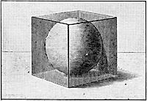

Some have interpreted “in Christ,” for example, as a physical locative metaphor for some sort of corporate mystical union between the believer and Christ ... Another is a spherical use, according to which it is said that one is in the sphere of Christ’s control … The spherical sense often shows that humans belong to particular realms, for instance, the one controlled by Adam and his actions and the one controlled by Christ and His. (S. Porter)

In 1 John 5:19, “the world lies in (en) the evil one,” suggests that it is at least possible that the preposition may mean “in the power of.” The man was “in” his own territory, just as the French in 1940-44 were “in” their own country and yet “in” the power of the Germans. We thus have the picture of “occupied country,” a not unfitting description of the sinful believer. (R. Ward)

To designate the abundant “power of Christ,” which flowed through him and took effect from him, Paul used a well-known technical religious word, the Greek term pistis, which we are accustomed to translate “faith.” The faith of Paul is then the union with God which is established in fellowship with Christ. God-intimacy in Christ Jesus, God-intimacy of those who are Christ-intimates: that is Paul’s faith.

[This faith does not refer to initial faith in Christ, but to continuing faith in Christ. Continuing faith in Christ is not some nebulous activity worked-up in the soul, but a gradual and cumulative acquisition of knowledge about Him. This faith, therefore, merges into the content of what is believed: biblical doctrines from the mind of Christ.]

In the older study of Paul it was generally the custom first to isolate the so-called ‘concepts’ of justification, redemption, reconciliation, forgiveness, and so forth, and then from these isolated and thereby theologically stiffened ‘concepts’ to reconstruct the ‘system’ of Pauline doctrine. In our conception of it there are straight lines, but they do not form closed geometrical figures, rather like rays of light, unlimited and immeasurable, they stream in all directions from the central point, the light of the experience of Christ.

* The light of the experience of Christ is increased by learning doctrinal concepts.

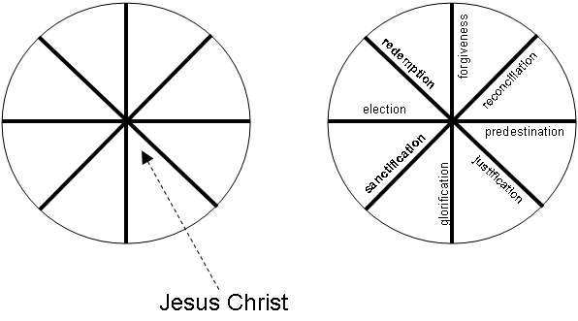

In the numberless confessions about Christ which follow one another without system in the letters of Paul, the reference is not to a diversity of many objects but to a diversity of the psychological reflections of the one object of religion. To this one object the confessor bears witness in a continually new variation of figurative words of similar meaning and often with the parallelism of prophetic emphasis. And it is our business to grasp the figurativeness, the ancient popular pictorial characters of these testimonies.

[The above pictorial selected only a few doctrines related to Paul’s expression for salvation in Christ. There are many other concepts that could be added. One could also duplicate this sphere and, for example, make the radii: (1) the attributes of God, (2) a system of experiential sanctification, (3) the attributes of Satan, (4) a system of embracing the world, the flesh, and the devil, etc.]

As an enemy, man stands before God in another set of metaphors. In place of that doctrinaire misconstruction of the mystically-local “in” in the formula “in God,” “in Christ Jesus,” and which at one time dominated the commentaries, we are now offered a wonderful and thoroughly sympathetic understanding of it in another pictorial.

The same is true also of their original prototype, the Pauline certainty in Christ. All that is essential to the religion of the Apostle, in so far as it is definable in that phrase, can be set forth clearly in the following contrasting diagrams. Here are the “old” Paul’s seven spheres of evil, and the “new” Paul’s one sphere of salvation.

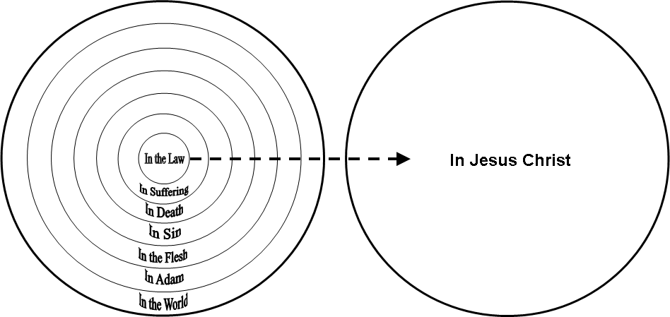

* The first diagram shows the seven spheres of evil apart from salvation in the experience of the “old” Paul.

* The second diagram shows the one sphere of salvation in the experience of the “new” Paul.

Almost all of these noble words (which for us today have largely lost their original vivid pictorial sense) can have their meaning displayed graphically.

Living in Christ, Paul divides his life into two great periods, that of the old Paul and that of the new created Paul. Here in one glance it can be seen what the essence of [positional] Pauline Christianity is: the certainty that one has been released from that dark many-walled prison of the seven spheres of evil, and rescued into the place of light and freedom, the one sphere of salvation in Christ. There is nothing important about the number seven, but in any case these seven spheres are mentioned repeatedly in Paul’s letters.

The greatest of all the concentric spheres of evil, which surrounds and closes in the others, is the cosmic circle. When that alone is realized in its naked terror, the depth of wretchedness enclosed in it is indicated by the words of Ephesians 2:12:

“Separate from Christ in the world, without hope, without God.”

When, on the other hand, the one sphere of salvation, Christ, is realized, all that can be experienced of salvation is summed up in the confession “hid with Christ in God” in Colossians 3:3. The normal condition in the world of being god-forsaken is changed in Christ in fellowship with God, as seen in the two following diagrams.

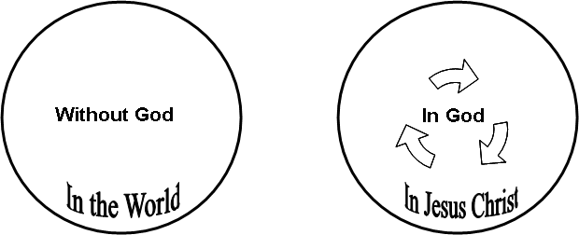

In Christ we are given “access” to God, for the “gates” of the sanctissimum are thrown open. God intimacy in Christ-intimacy.

The “new man” lives and works “in Jesus Christ” within the sphere of light and holiness, into which all the dark terrors cannot reach. But the justified man is not a completely righteous man: he still has a goal of righteousness before him. This is where the “doctrine” of God and of Christ should be discussed, as well as “sharing the sufferings of Christ.” Springing out of fellowship with Christ is a multitude of separate assurances of Christ … a growing understanding in the soul of the mysteries that were hidden in the person of Christ.

[As Christians we are all intended to understand these “mysteries that were hidden in the person of Christ.” As Church Age believers, we are peculiar, privileged and protected. We have a plan that we are to persevere in. Before leaping from Deissmann to Thieme, I am inserting a brief study by Kenneth Wuest. I believe his ideas will ease the transition from the use of basic pictorials to more detailed pictorials related to Christ-intimacy.]

The word “peculiar” is found in Titus 2:14. Christians are the peculiar people of God. We use the word sometimes when we speak of something odd or strange. But that is not its use here. The word is translated from a Greek word which is made up of two words, one which means “around,” as a circle, and the other which means “to be.” It can be charted by a dot within a circle. This will help us to understand the meaning of the combined word.



As the circle is around the dot, so God is around each one of His saints. The circle monopolizes the dot, has the dot all to itself. So God has His own all to Himself. They are His own private unique possession. He has reserved them for Himself. The expression in 1 Thessalonians 1:1, “The church of the Thessalonians in God,” has in it the same idea, for the Greek case is Locative of Sphere. That is, it is in the sphere of God, circumscribed by God, surrounded by Him.

This is a place of high privilege. In 2 Peter 2:7, the Greek has it, “Unto you who believe, is the preciousness.” That is, the preciousness of Jesus is imputed to us. He becomes our preciousness in the eyes of the Father as He becomes our righteousness before the law. The Son dwells in the bosom of the Father, closest to the Father’s affections. Marvelous grace, that we sinners saved by grace are bought into that favored place closest to the Father’s affections. The Father loves us as much as He loves His only begotten Son. What a pillow on which to rest our weary hearts when going through a testing time.

This is also a place of protection. Place a dot outside of the circle, and draw an arrow from that dot to the dot inside the circle. Label that dot a temptation. As the arrow cannot reach the dot except it goes through the circle, so no temptation can reach us except it goes through the permissive will of God first. As we walk in the center of God’s will, He will not permit the Devil to confront us with a temptation too great for us, but will provide us with the necessary faith and spiritual strength to overcome it. Victory over sin is a guaranteed fact when we are in the center of God’s will.



Put another dot outside the circle. Run an arrow to the dot inside. Label the outside dot “a trial” or “testing time.” As the arrow cannot reach the dot inside unless it goes through the circle, so no time of testing, no sorrow, can reach the child of God who dwells in the center of His will, unless it comes through the permissive will of God, and when it reaches us, God sees to it that all needed grace is given to bear that trial. He is the God of all grace who comforts us in all our afflictions … The grace of God is sufficient to surmount every difficulty, comfort any sorrow, overcome any temptation.

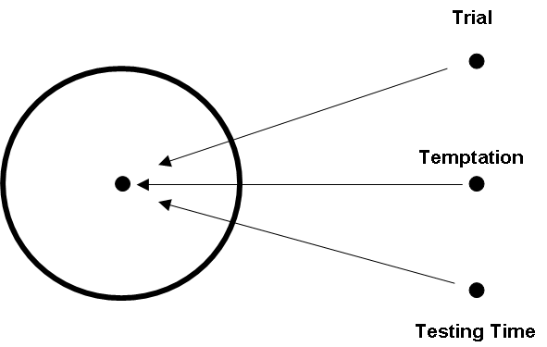

The Christian is exhorted to walk in the Spirit. The word “walk” is used in an early Greek manuscript in the sentence, “I am going about in a disgraceful state.” The writer of this sentence was commenting on the kind of life he was living, how he was conducting himself. The form in the Greek shows that it is a command to be constantly obeyed. “Be constantly conducting yourselves in the Spirit.” The word “Spirit,” referring here to the Holy Spirit, is in the Locative of Sphere, and could be charted by a dot within a circle. The dot is ensphered within the circle. The exhortation therefore is, “Be constantly conducting yourselves in the sphere of the Spirit.” That is, determine every thought, word, and deed by the leading of the Spirit through the Word, and think every thought, speak every word, and do every deed, in an attitude of entire dependence upon the Holy Spirit’s empowering energy, “Bringing into captivity every thought to the obedience of Christ” (2 Cor. 10:5).

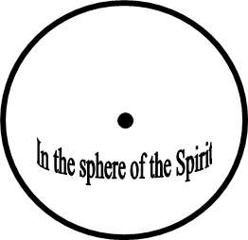

If we do this, we have God’s guarantee and promise that we shall not fulfill the lust of the flesh … As we determine our conduct by what the Spirit leads us to do, and yield to Him for the divine energy with which to do it, we have God’s promise that we will not fulfill the cravings of the fallen nature.

[With Wuest’s simple pictorials on “walking in the Spirit,” “resisting temptation,” and “persevering through trials and testing times” behind us, now we move on to more advanced concepts related to Christ-intimacy. To understand the “mysteries that were hidden in the person of Christ” we will turn to a new set of vocabulary words and more elaborate pictorials coined and created by Robert B. Thieme, Jr. But first a few words on philology by Deissmann.]

There appears, more or less clearly, the tendency to establish new “biblical” or “New Testament” words, or new “biblical” or “New Testament” meanings of old Greek words. That there are “biblical” and “New Testament” words – or, more correctly, words formed for the first time by Greek Jews and Christians – and alterations of meaning, cannot be denied. Every movement of civilization which makes its mark in history enriches language with new terms and fills the old speech with new meanings.

The natural course is to betake oneself placidly to the hypothesis of ordinary usage. However, Hermann Cremer and others that have followed him historically … propose to offer, towards the understanding of the New Testament, positive materials from the approximately contemporary products of later Greek, and to assist, in what degree they can, in the liberation of biblical study from the bonds of tradition … taking up again, one might say, the work of the industrious collectors of “observations” in the last century ... in the interest of the philologico-historical investigation of the Greek Bible … with a great opportunity for the ascertaining of new facts.

[That’s a fancy way of saying that we are going to use a lot of new theological vocabulary that was derived from the Greek and Hebrew language. This sort of thing has been going on for centuries in Christian thought, but has ground to a near halt in the past century in theological seminaries. The theological discipline traditionally called experiential sanctification (Christ-intimacy) needs an infusion of new technical vocabulary in order to better communicate this long-neglected area of study. I like Thieme’s new technical vocabulary words; I use them profusely. So let’s look at three of his charts that relate to this Christ-intimacy.]

In the first chart that follows, the Top Circle represents our eternal relationship with God. Once we believe in Jesus Christ, salvation can never be forfeited. Once we have believed in Jesus Christ, we cannot lose our salvation. The moment we believe, the Holy Spirit places us into union with Christ, the irrevocable state of eternal relationship. The Scripture designates this union with Christ by the phrase “in Christ.”

The Bottom Circle represents fellowship with God in time. Fellowship with God provides the means to live the Christian life and grow spiritually. Unlike the top circle, the believer by his own volition can remove himself from the bottom circle. Inside the bottom circle represents spirituality; outside represents carnality … Every time we decide to sin we move out of the bottom circle losing temporal fellowship. By acknowledging our sins to God the Father we return to the bottom circle.

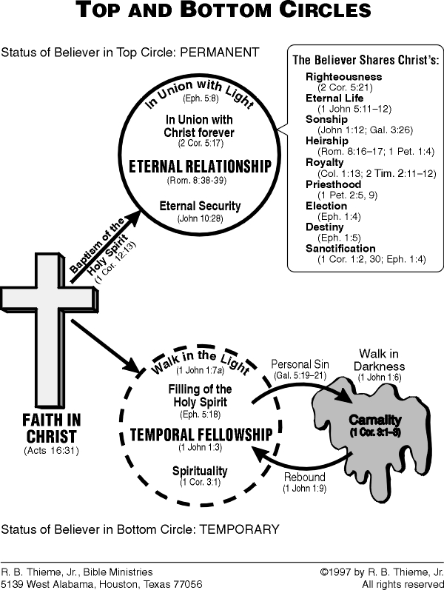

[In the second chart that follows, we “explode” the bottom circle, as it were, to see its inner workings in greater detail. Thieme combines the use of the word “gates” as mentioned earlier by Deissmann, with the Locative of Sphere and the Greek word dunamis or “power.” Dunamis + sphere = Dynasphere, one of Thieme’s ingenious words for residence and function in the Spirit and in Christ. Thieme wasn’t the first person to use the word dynasphere. Science fiction writer Victor Appleton II coined the word in another context in a 1950’s book for teenagers, called Tom Swift and His Polar-Ray Dynasphere. I don’t know if there’s any connection, but I wouldn’t be surprised. ☺ The word was also used in the 1970’s in the computer industry as a coding solution in spherical geometry dealing with national defense, i.e., the use of electromagnetic pulses. It is also a word used in nuclear physic related to elementary particles in four-dimensional space. This may be where Victor Appleton first heard the word. Recently, a group of international electrical engineers has used the word to describe an electro-magnetic device they have been testing in New Mexico, the dynasphere 3000.]

[There is a U.S. patent for a dynasphere that protects a building against lightning strikes. Dr. Charcot, a French psychologist interested in psychic research, tried to measure what was commonly called “dynaspheric force” through hypnotism. In Christian terms, he was trying to measure an invisible magnetism in two types of individuals: those filled with the Spirit and those possessed by demons. Yes, even the occult has toyed with the word. Why wouldn’t they? Satan has two cosmic dynaspheres by which he controls man. There have been attempts by esoterics to measure and utilize “dynaspheric force” for hundreds, perhaps thousands of years. It has been labeled as an “interatomic energy” that “produces the phenomena of hypnotism, telepathy, mediumship, and the abnormal manifestations which characterize occultism and oriental magic,” which is called by various other names such astral fluid, chi, soma, psychic matter, unseen energy, pneumatic vibration, odylic sphere, dielectrics … the list goes on and on. Don’t kid yourself for one minute; Satan is alive and well on planet earth. He has his own “sphere of power,” his own “dynaspheres,” and there is no lack of interest in his system on earth today.

But that doesn’t mean the use of Greek words as a teaching aid is automatically a condemned practice! You can easily find satanic cults who use some of the same vocabulary found in the Bible for their false teaching. There are pneuma cults, agape cults, kurios cults, dunamis cults, theos cults, pistis cults, gnosis cults, logos cults, ecclesia cults, baseleia cults … the list goes on and on. Paul and Peter continually battled some of these false teachings. Some of them even wrote heretical papers and tried to forge Paul’s name on them to gain inroads in Christian circles. I mention some of these other uses of Greek words because some people raise their eyebrows and get silly when encountering new vocabulary words, especially in Christian circles. So before you run around acting like a nut-job, gossiping and maligning someone who uses new vocabulary or graphic teaching aids you haven’t seen before, do your homework.]

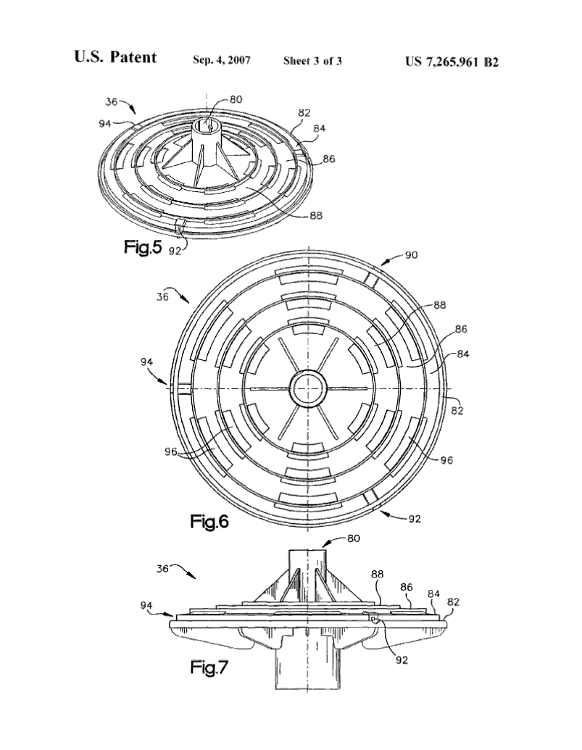
[There’s also been a study of “vibrations” by those with an occult background, which led to the construction of a machine that was once touted as a replacement for the steam engine. It didn’t happen, although there are apparently some individuals still trying to apply the theory according to some blogs. Below is a photo of a Keely dynasphere, I think. Just reading about it gives me a headache



It should be obvious that none of this has anything to do with Thieme’s use of the word, but I know there are some of you out there who like such trivia. And yes, there are some kooks out there who claim to have “gone beyond” these teachings – to what, it’s hard to tell. It appears they have jettisoned a lot of conservative Christian theology by men such as Chafer and Pentecost from Dallas Theological Seminary whom I hold in highest regard. Also, for those who are wondering … I have a copy of Wall’s book. It has a few good points in it, but for the most part I think it’s a waste of paper. There is no end to the number of people who react unfavorably to the teachings and ministry of others and then distort their message in revenge motivation.

There was even a car designed by a man name Purve called the dynasphere. It’s a small photo (below), but you actually ride inside the tire. I did not find a picture of it, but there was an adaptation of this “car” in which six people could ride inside it at the same time.]



Thieme’s use of the word dynasphere is really quite simple. God has a system of love (John 15:10) and power (Eph. 6:10-11) that we are repeatedly commanded to live in. This system is “entered into” by the private confession of sin to God (1 John 1:9) with the resultant filling of the Spirit. There are a large number of Bible verses that describe this system (modus operandi) and which add more details as to how we are to live (modus vivendi) in this sphere of divine love and power. Some of these commands from God … such as to be genuinely humble, to love the brethren, to endure suffering, to study the Word of God, to apply doctrine to daily life … Thieme represents as gates in the sphere of love and power. You enter a particular gate when you are obedient to that mandate. For example, the next diagram called the divine dynasphere is a teaching aid to help believers understand how to live the Christian way of life according to a set of biblical mandates from God. It is called divine because as we have just seen, there is a devilish system of power also in existence.

If you don’t like this pictorial teaching aid, by all means don’t use it! You can go through the NT book-by-book and outline His divine mandates for the Church Age dispensation and teach them without this or any other pictorial teaching aids. You can compile verse-upon-verse, concept-upon-concept, in whatever manner you wish if it helps you to assimilate God’s truth. As for me, I like teaching aids, especially pictorials. Until someone develops better ones, I’m going to continue using those developed by Deissmann, Wuest, Porter, Thieme, and anyone else who creates an innovative way of explaining complicated biblical concepts to positive believers.

The commands of God are like gates that open upon divine assets. The believer passes through these gates and uses his God-given assets by consistently learning and obeying God’s mandates, by following divine protocol. Obedience to divine authority puts the power of God into effect in the believer’s life.

Although hundreds of divine mandates for the royal family are found in the New Testament, all of these commands can be classified into eight categories. I call these categories the gates of the believer’s magnificent, invisible palace. The divine dynasphere consolidates God’s mandates for the Christian life into one consistent, comprehensive system.

Gate 1 is the silent, invisible, enabling ministry of the Holy Spirit. Omnipotent God the Holy Spirit sustains the believer, supplying the supernatural means of executing the supernatural Christian way of life.

Gate 2 is basic Christian modus operandi, the first of which is the confession of sin (rebound) to God the Father as a means of restoring temporal fellowship with God after sin has broken that fellowship. It also includes the faith rest drill, in which the believer mixes the promises of God with faith and thinks rationally to reach doctrinal conclusions.

Gate 3 is enforced and genuine humility, which makes the believer teachable one way or another.

Gate 4 is the momentum gate, designed for the intake, metabolism, and application of Bible doctrine, which cause spiritual growth and personal love for God.

Gate 5 is the gate of spiritual self-esteem, where the strength of soul that comes from personal love for God motivates the Christian’s life spiritually.

Gate 6 is the gate of spiritual autonomy, characterized by impersonal love for other people. Impersonal love is the foundation for every correct mental attitude toward people.

Gate 7 is the gate of momentum testing, which involves suffering which accelerates the believer’s advance in the spiritual life.

Gate 8 is the winner’s gate, the gate of spiritual maturity. In this gate, God is glorified and the believer is blessed to the maximum in all circumstances, whether prosperity or adversity.

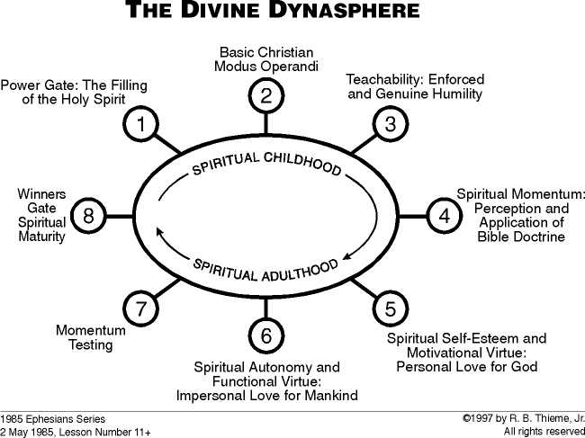

[These definitions of Thieme’s eight gates of the divine dynasphere are just the surface of a thoroughly detailed study in systematic theology commonly referred to as experiential sanctification, or Christ-intimacy. It is not my intention to reproduce all of his teachings on the subject here, since there are entire volumes and literally hundreds of hours of teaching on this topic available through his ministry. I will, however, review a third and last chart which categorizes compartments in the believer’s soul as well as the process of applying Bible doctrine to life through divine problem-solving devices.]

The problem-solving devices are the God-given means of accurate and correct application of doctrine to experience. They prevent the inevitable outside pressures of adversity from overwhelming your soul. Operation of these devices begins with your recovery from carnality. Restored to fellowship with God, your spiritual life is empowered for advance. As you acquire epignosis knowledge, you incorporate the problem-solving mechanics for leading a life of meaning, purpose, definition and fulfillment of God’s plan. Whether surrounded by adversity or prosperity, you can solve every human problem by deploying the appropriate combination of these ten devices.

- Rebound: the confession of sin in 1 John 1:9
- Filling of the Spirit: empowers you to apply Bible doctrine and execute His plan
- Faith-rest drill: claim the promises of God, persevere in testing
- Grace orientation: maintaining genuine humility and a relaxed mental attitude
- Doctrinal orientation: consistent inculcation and application of doctrine to life
- Personal sense of destiny: passing providential preventative suffering
- Personal love for God the Father: passing momentum tests
- Impersonal love for mankind: virtue takes precedence over the flaws of people
- Sharing the happiness of God: passing evidence tests
- Occupation with Jesus Christ: the Lord becomes your best friend

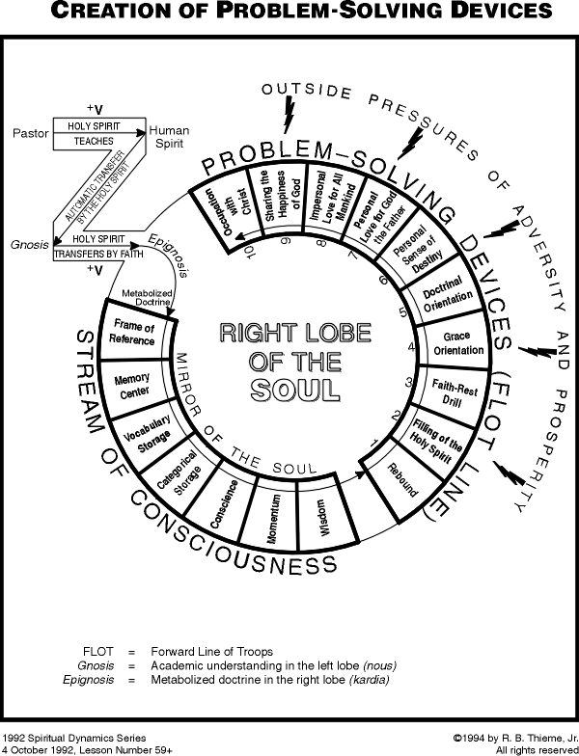

[Christ-intimacy or experiential sanctification is an entire category of systematic theology. As you might guess, there is a considerable body of work behind this topic, as can be readily seen by the last three pictorials. A considerable number of other charts, teaching aids and tapes by Robert B. Thieme, Jr. are available through his website http://www.rbthieme.org/illustra.htm. I highly recommend them.

Some people find it difficult to make the leap from Deissmann’s simple pictorials on Christ-intimacy to Thieme’s more elaborate mechanics of the Christian way of life. For that very reason, I have a recommended reading list for those who wish to pursue this topic more thoroughly. Please see the Rehab page of my website www.versebyverse.com and search for EXPERIENTIAL SANCTIFICATION READING MATERIAL.]

Resources

Paul: A Study in Social and Religious History, G. Adolf Deissmann, 1957, Harper Torchbooks, Harper & Row Publishers

Bible Studies: Contributions Chiefly from Papyri and Inscriptions to the History of the Language, the Literature, and the Religion of Hellenistic Judaism and Primitive Christianity, G. Adolf Deissmann, 1988, Hendrickson Publishers

Golden Nuggets: Wuest’s Word Studies From the Greek New Testament, Kenneth S. Wuest, 1994, Wm. B. Eerdmans Publishing Company

Rebound & Keep Moving, Christian Suffering, Freedom Through Military Victory, Grace Apparatus Perception, Robert B. Thieme, Jr., 1974-2002, R.B. Thieme, Jr. Bible Ministries, Houston Texas

Syntax of New Testament Greek, James A. Brooks & Carlton L. Winbery, 1979, University Press of America

An Idiom Book of New Testament Greek, C.F.D. Moule, 1994, Cambridge University Press

Idioms of the Greek New Testament, Stanley E. Porter, 1996, Sheffield Academic Press

Hidden Meaning in the New Testament: New Light from the Old Greek, Ronald A. Ward, 1969, Fleming H. Revell Company

User's Manual for the DYNASPHERE SGEMP Computer Code, Andrew J. Woods, 1976, United States Dept of Defense: Defense Technical Information Center

The Irreducible Volume Character of Events: A Theory of the Elementary Particles and of Fundamental Length, B.T. Darling, 1950, Mendenhall Laboratory of Physics, Ohio State University

Scientific Religion or Higher Possibilities of Life and Practice Through the Operation of Natural Forces, Laurence Oliphant, 1888, Kessinger Publishing

Systematic Theology, Volume 6: Pneumatology, Lewis Sperry Chafer, 1993, Kregel Publications

